METHODOLOGY

·Spiral methodology:
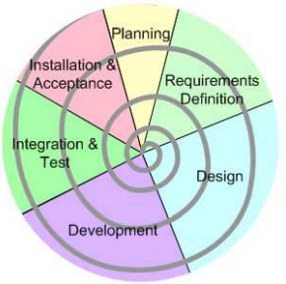
In our case we decided make a small part of all phases of the project and use the spiral methodology for the following reasons:

- Avoid the large initial design.
- We can know the reaction of the customer faster and before.
- We test before the most dubious functions.
- We can deliver customer product parts. With this we have two benefits:
· We have less risk.
· The client can enjoy before the product

At every turn or iteration we must keep in mind:
-Objectives
-Alternatives: The different ways to get the objectives in order to achieve product success.
-Develop and Verify: Programming and test the software.

Scrum roles.

Development Team: Produce the deliverables parts of product at the end of the 'sprints'.
Responsible → Irene Blanco Fabregat and Juan Antonio Muñoz Fernandez

Product Owner: Represents the interests of the client. Should define the 'Product Backlog' items.
Responsible → Juan Antonio Muñoz Fernandez

Scrum Master: Ensures that all sprints and product deliveries are adopted correctly.
Helps to understand and follow the Scrum team.
Responsible → Irene Blanco Fabregat

